Digital Logic Design Laboratory

Lab 3

MSI Combinational Logic (II)

Full name: Đỗ Minh Duy

Student number: ITITSB22029

Class: DLD LAB

Date: 3/5/2024

# I. Objectives

In this laboratory, students will study:

- Understand the operation of combinational logic circuit.

- The operation of some combinational ICs such as: full adder, decoder, encoder.

# II. Procedure

1. Design the adder with two one-bit binary.

a. Design the half adder two one-bit binary.

Two inputs are A, B. Two outputs are S and C.

Build the truth table and the expressions

|  |  |  |  |
| --- | --- | --- | --- |
| A | B | S | C |
| 0 | 0 | 0 | 0 |
| 0 | 1 | 1 | 0 |
| 1 | 0 | 1 | 0 |
| 1 | 1 | 0 | 1 |

The simplified expressions:

S = A⊕B (XOR gate)

C = A.B (AND gate)

Implement the circuit via simulation software and paste the result in here

Make comment on the results

The sum (S) is 1 when the number of input bits that are 1 is odd.

The carry (C) is 1 only when both input bits are 1

b. Design the full adder two one-bit binary.

Three inputs are Cin, A, B. Two outputs are S and Cout.

Build the truth table and the expressions

|  |  |  |  |  |
| --- | --- | --- | --- | --- |
| A | B | Cin | S | Cout |
| 0 | 0 | 0 | 0 | 0 |
| 0 | 0 | 1 | 1 | 0 |
| 0 | 1 | 0 | 1 | 0 |
| 0 | 1 | 1 | 0 | 1 |
| 1 | 0 | 0 | 1 | 0 |
| 1 | 0 | 1 | 0 | 1 |
| 1 | 1 | 0 | 0 | 1 |
| 1 | 1 | 1 | 1 | 1 |

The simplified expressions:

S = (A⊕B) ⊕ C

Cout = AB + (A⊕B) ⊕ C

Implement the circuit via simulation software and paste the result in here

Make comment on the results

The first two inputs are labeled A and B, while the third input is called C-IN. The output provides a SUM, and C-OUT is activated only when two or more of the three inputs are in a HIGH state. Thus, C-OUT will be activated under these circumstances.

2. 8-to-3 Priority Encoder (Interrupt sorter) – IC 74HC148

a. Investigate IC – 74HC148

Construct the circuit as below:

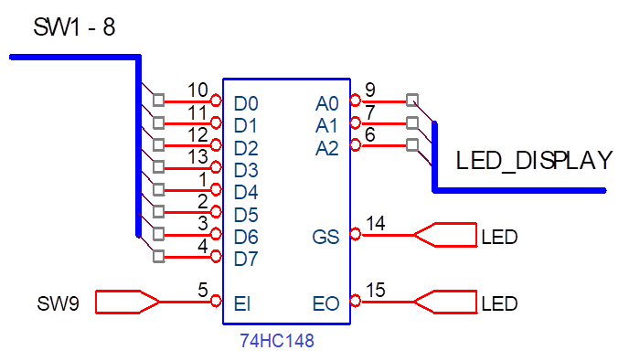

Figure 1 – Encoder 8-to-3 IC 74LS148

- The outputs are connected to LED displays to determine the logic levels.

- Choose the input data D0 - D7 by switches in the order from SW0 to SW7.

- Control EI by using switch.

- Observe the results and fulfill the truth table of 74HC148.

- What are the functions of  and ?

|  |  |  |  |  |  |  |  |  |  |  |  |  |  |
| --- | --- | --- | --- | --- | --- | --- | --- | --- | --- | --- | --- | --- | --- |
| Input | | | | | | | | | Output | | | | |
| EI | D0 | D1 | D2 | D3 | D4 | D5 | D6 | D7 | GS | A2 | A1 | A0 | E0 |
| 1 | X | X | X | X | X | X | X | X | 1 | 1 | 1 | 1 | 1 |
| 0 | 1 | 1 | 1 | 1 | 1 | 1 | 1 | 1 | 1 | 1 | 1 | 1 | 0 |
| 0 | X | X | X | X | X | X | X | 0 | 0 | 0 | 0 | 0 | 1 |
| 0 | X | X | X | X | X | X | 0 | 1 | 0 | 0 | 0 | 1 | 1 |
| 0 | X | X | X | X | X | 0 | 1 | 1 | 0 | 0 | 1 | 0 | 1 |
| 0 | X | X | X | X | 0 | 1 | 1 | 1 | 0 | 0 | 1 | 1 | 1 |
| 0 | X | X | X | 0 | 1 | 1 | 1 | 1 | 0 | 1 | 0 | 0 | 1 |
| 0 | X | X | 0 | 1 | 1 | 1 | 1 | 1 | 0 | 1 | 0 | 1 | 1 |
| 0 | X | 0 | 1 | 1 | 1 | 1 | 1 | 1 | 0 | 1 | 1 | 0 | 1 |
| 0 | 0 | 1 | 1 | 1 | 1 | 1 | 1 | 1 | 0 | 1 | 1 | 1 | 1 |

Implement the circuit via simulation software and paste the result in here

b. Priority encoder

Let’s EI equal to 0, fill the outputs A2, A1, A0 in the following cases

|  |  |  |  |
| --- | --- | --- | --- |
|  | A2 | A1 | A0 |
| Case 1:  I3 = I2 = I1 = 0  I7 = I6 = I5 = I4 = I0 = 1. | 0 | 0 | 1 |
| Case 2:  I7 = I2 = 0.  I6 = I5 = I4 = I3 = I1= I0 =1 | 0 | 0 | 0 |
| Case 3:  All 8 inputs are equal to 0. | 0 | 0 | 0 |

Case 1:

Implement the circuit via simulation software and paste the result in here

Make comment on results

E0 is in a HIGH state when E1 is in a low state, and not all of the inputs are in a

HIGH state.

When only A2 is in a high state, D0, D4, D5, D6, and D7 are currently in a high

state because the priority encoder initiates checking from D7. If D7 is in a high

state, the encoder proceeds to check other inputs, stopping when an input is in a

low state. Only A2 and E0 are in a high state, with D7 holding the priority..

Case 2:

Implement the circuit via simulation software and paste the result in here

Make comment on results

Base on the case 1’s comment on case 1, D7 still holding priority. E0 is the only output show high.

Case 3:

Implement the circuit via simulation software and paste the result in here

Make comment on results

The comment still the same as the previous response, D7 still priority, E0 is the only output show high

3. 2-to-4 Decoder - IC74HC139

Construct the circuit as below:

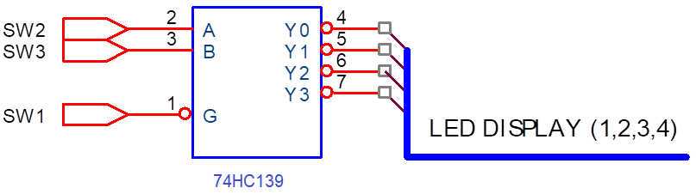

Figure 2 – Decoder 2-line-to-4-line IC 74HC139

- 4 outputs (Y0-Y3) are connected to LED display (Led 1-4).

- The data inputs (A, B) and control input (G) are connected to switches.

- Change the states of inputs to fulfill the truth table of IC 74HC139.

|  |  |  |  |  |  |  |
| --- | --- | --- | --- | --- | --- | --- |
| Inputs | | | Outputs | | | |
| Control | Data | |
| G | B | A | Y0 | Y1 | Y2 | Y3 |
| 0 | 0 | 0 | 0 | 1 | 1 | 1 |
| 0 | 0 | 1 | 1 | 0 | 1 | 1 |
| 0 | 1 | 0 | 1 | 1 | 0 | 1 |
| 0 | 1 | 1 | 1 | 1 | 1 | 0 |
| 1 | X | X | 0 | 0 | 0 | 0 |

Implement the circuit via simulation software and paste the result in here

Briefly describe the operation of the IC

The IC 74HC139 decodes two binary-weighted addresses from two inputs (A00, A01) into four distinct outputs (Y00 to Y03). Each decoder includes an enable input (E0), and when E0 is set to a HIGH state, all outputs are compelled to be in a HIGH state.

4. 3-TO-8 Decoder– IC 74HC138

Construct the circuit as below:

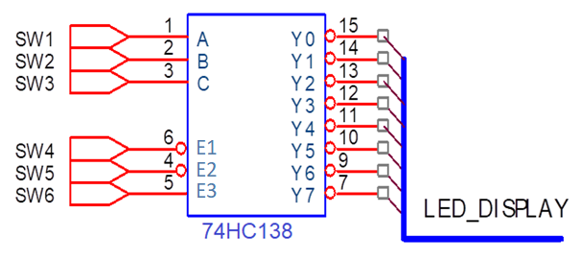

Figure 3 – 3-to-8 Decoder/demultiplexer - IC 74HC138

- 8 outputs are connected by using LEDs.

- The inputs are controlled by switches.

- Observe the results and fulfill the truth table

|  |  |  |  |  |  |  |  |  |  |  |  |  |  |
| --- | --- | --- | --- | --- | --- | --- | --- | --- | --- | --- | --- | --- | --- |
| INPUT | | | | | | OUTPUT | | | | | | | |
| E3 | E2 | E1 | C | B | A | Y0 | Y1 | Y2 | Y 3 | Y4 | Y 5 | Y 6 | Y7 |
| 1 | 0 | 0 | 0 | 0 | 0 | 0 | 1 | 1 | 1 | 1 | 1 | 1 | 1 |
| 1 | 0 | 0 | 0 | 0 | 1 | 1 | 0 | 1 | 1 | 1 | 1 | 1 | 1 |
| 1 | 0 | 0 | 0 | 1 | 0 | 1 | 1 | 0 | 1 | 1 | 1 | 1 | 1 |
| 1 | 0 | 0 | 0 | 1 | 1 | 1 | 1 | 1 | 0 | 1 | 1 | 1 | 1 |
| 1 | 0 | 0 | 1 | 0 | 0 | 1 | 1 | 1 | 1 | 0 | 1 | 1 | 1 |
| 1 | 0 | 0 | 1 | 0 | 1 | 1 | 1 | 1 | 1 | 1 | 0 | 1 | 1 |
| 1 | 0 | 0 | 1 | 1 | 0 | 1 | 1 | 1 | 1 | 1 | 1 | 0 | 1 |
| 1 | 0 | 0 | 1 | 1 | 1 | 1 | 1 | 1 | 1 | 1 | 1 | 1 | 0 |
| 0 | X | X | X | X | X | 1 | 1 | 1 | 1 | 1 | 1 | 1 | 1 |
| X | 1 | X | X | X | X | 1 | 1 | 1 | 1 | 1 | 1 | 1 | 1 |
| X | X | 1 | X | X | X | 1 | 1 | 1 | 1 | 1 | 1 | 1 | 1 |

Implement the circuit via simulation software and paste the result in here

Briefly describe the operation of the IC

The 74HC138 processes a three-bit binary-weighted address from inputs A0, A1, and A2. When enabled, it generates an active-low output, and the remaining seven outputs are set to a HIGH state

5. Design combinational circuits using decoders and OR gate

- Implement Boolean expression using IC 74HC138 & OR gate.

- The data inputs A, B, C are connected to switches.

- The control inputs are in suitable levels.

- Implement the circuit and verify the truth table

a.

Establish the truth table

|  |  |  |  |
| --- | --- | --- | --- |
| x | y | z | F |
| 0 | 0 | 0 | 0 |
| 0 | 0 | 1 | 0 |
| 0 | 1 | 0 | 1 |
| 0 | 1 | 1 | 0 |
| 1 | 0 | 0 | 0 |
| 1 | 0 | 1 | 1 |
| 1 | 1 | 0 | 0 |
| 1 | 1 | 1 | 1 |

Implement the circuit via simulation software and paste the result in here

Verify the truth table and make comment on the results

b.

F=x’yz + x(y+y’)(z+z’) +(x+x’)y’z’

…

F= x’yz+xyz+xy’z+xyz’+x’y’z’+xy’z’+ x’y’z’

Σf= (0,3,4,5,6,7)

Establish the truth table

|  |  |  |  |
| --- | --- | --- | --- |
| x | y | z | f |
| 0 | 0 | 0 | 1 |
| 0 | 0 | 1 | 0 |
| 0 | 1 | 0 | 0 |
| 0 | 1 | 1 | 1 |
| 1 | 0 | 0 | 1 |
| 1 | 0 | 1 | 1 |
| 1 | 1 | 0 | 1 |
| 1 | 1 | 1 | 1 |

Implement the circuit via simulation software and paste the result in here

Verify the truth table and make comment on the results

- There are 6 high states of the output of IC 74HC138 & OR gate:

- In the first state x is low , y is low , z is low

- In the second state x is low, y is high, z is high

- In the third state x is high , y is low , z is low

- In the fourth state x is high , y is low, z is high

- In the firth state x is high , y is high, z is low

- In the sixth state x is high , y is high , z is high